Krakatau for C/C++ and Java

Management Overview_
1 Introduction
2 Software Metrics
3 Krakatau Metrics
4 Using Krakatau
5 Integrating Krakatau Into Your Existing Environment
6 Business Benefits
7 For Further Information

1 Introduction

As software lifecycle costs continue to increase, control over software projects is increasingly important.

This paper introduces Krakatau for C/C++ and Java, the Integrated Software Measurement Environment. Krakatau is helping global organisations to control their software development process and improve quality in new and existing projects.

In any engineering project, the goal is to create a product exhibiting the attributes known to represent ‘quality’ while effectively controlling costs and resources. For software, these quality attributes include maintainability, reusability, testability and comprehensibility. Developers and managers understand these quality attributes and need ways to measure them across projects. Quality can be affected by complex interactions within the source code which are almost impossible to measure by hand. Krakatau helps measure these attributes continually to ensure that the source code quality is preserved as the project grows and changes.

Krakatau delivers real productivity gains because it offers quality analysis and improvement in a package so easily accessible, it becomes part of every developer’s daily quality process.

Krakatau has been designed for use on every developer’s desk.

2 Software Metrics

Software metrics allow developers and managers to monitor quality across project lifecycles. Software metrics assign quantitative values to quality concepts. Since the 1970’s, the software industry has developed many ways to measure quality attributes numerically. At the simplest level, one can measure the size of a code base by counting lines of code. At a more advanced level, the reusability of a class in an object-oriented system can be assessed by considering coupling and other interactions between the class and the rest of the system. Other attributes such as testability can be measured by looking at the complexity, structure, encapsulation and interactions of a component.

Modern software projects contain hundreds of thousands, even millions of lines of code and it is almost impossible to make even simple measurements by hand. More complex metrics, such as those that analyse complex interactions between components need to be measured with an automated tool. Krakatau has been designed to provide this essential functionality.
3 Krakatau Metrics

Krakatau for C/C++ and Java enables organisations to monitor and improve software quality by addressing their quality needs including:

- access to a comprehensive suite of metrics addressing all aspects of software quality.
- automated tools to apply metrics quickly and reliably.
- graphical interface for intuitive access to results.
- command-line interface for optional batch processing.
- facilities to search, sort and graph results to identify areas of possible improvement.
- filtering to allow focus on areas of interest.
- facilities to create reports showing quality across whole projects.
- scalability to manage large projects.
- software which does not intrude into existing environments.
- software so simple to set up that it is part of your system in minutes rather than days.
- software so easy to use that it becomes part of every developer’s daily quality process.

Krakatau brings together the most popular software metrics suites in a single tool including:

- Halstead Software Science Metrics
- CK Metrics Suite (Chidamber & Kemerer)
- Lorenz & Kidd Metrics
- McCabe Complexity Metrics
- US STD MIL Metrics (DII COE)
- MOOD Metrics (Metrics for Object-Oriented Development)
- Chen & Lu Complexity Metrics
- Krakatau Language-Specific Metrics
- Krakatau Comment Metrics

The following sections describe how Krakatau is used to improve the quality process.

3.1 Software Lifecycle with Krakatau

Krakatau helps users throughout the project lifecycle. In the design phase, most CASE tools can generate header files which can be analysed by Krakatau for conformance to design metrics. During implementation, code can be checked against all the metrics as it is added to the project. Individual developers use Krakatau to validate code before it becomes part of the main source tree. Krakatau provides testability metrics which detect areas of code requiring greatest testing, allowing better resource allocation and shortening the testing phase. During maintenance, Krakatau is valuable in detecting areas of potential design improvement. By checking complexity and inter-relationships, Krakatau helps developers to ensure that new code which is added does not harm the quality of the overall project in any way.
4 Using Krakatau

Krakatau provides an intuitive graphical user interface to simplify project creation and result processing capabilities.

4.1 Setting up Projects

Project creation and maintenance in Krakatau has been designed to allow projects to be specified in an intuitive and simple manner. Projects in Krakatau are simply groups of source files selected by the user that can be altered at any time using Krakatau’s Project Editor. The source files contained in the project are treated as one logical unit. The user need not specify the files to be measured at every session, he simply loads his project and begins working.

For efficiency, Krakatau only reparses source files that have changed since the project was last accessed. This allows metrics to be updated incrementally rather than having to reparse the entire group of files at each session.
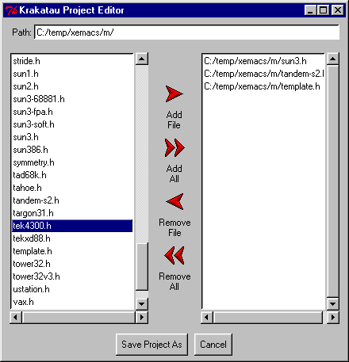

Figure: Project Editor

4.2 Searching, Sorting and Filtering Results

The Krakatau user interface has been designed to allow users access to the information they require as quickly as possible. Features include:

- Selection and customisation of metric set.
- User-configurable bound values.
- Exclusion of symbols/metrics that do not violate specified bounds.
- User-specified sorting of results based on selected metrics.
- Searching/filtering of results using regular expressions.

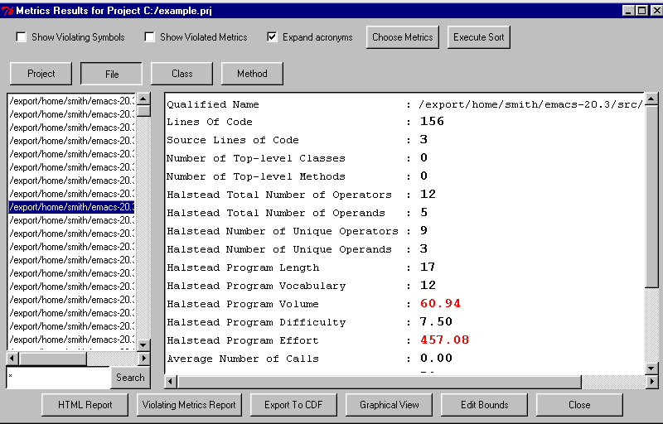
These are explained in more depth below. Together these provide the user with the power to quickly see areas of potential improvement in his code.

Figure: Numerical Results View

4.3 Customisable Metrics Suite

Krakatau provides the user with the ability to select the metrics they need from the comprehensive set that Krakatau provides. This allows the creation of subsets of metrics that can be implemented on a company-wide basis and can be easily incorporated into the company quality assurance program. Once specified, these metric sets can be saved for later use allowing different metric subsets to be created and applied with minimum effort.
4.4 User Configurable Bound Values

To utilise the full power of the Krakatau metrics, it is useful to have a set of standard metric values against which to benchmark the actual results from your code. Krakatau provides the opportunity to specify bound values for every metric providing an upper and lower threshold value to compare the metric results. Users select which bounds are necessary allowing freedom to leave bounds undefined. Once the bounds have been defined, Krakatau detects violations and displays them to the user through the numerical and graphical views, highlighting areas of code where potential improvements may exist. Bound values can be saved and recalled in a similar manner to metrics subsets.

4.5 Excluding Non-Violating Symbols

To highlight areas of potential improvement, it is useful to filter out symbols that give no cause for concern. Krakatau achieves this by comparing results against the specified bounds and showing only results that violate these bounds. This process works at both the symbol and metric level. Symbol level filtering removes from view all symbols that do not violate the specified bounds. This leaves only symbols which contain violating metrics values, i.e. those that are likely to be of most interest to the user. Metric level filtering removes from view, for each symbol, metrics results which do not violate the bounds, leaving only violating results. When used together, these filters allow easy navigation between areas of potential improvement by hiding non-critical information.

4.6 User-specified Result Sorting

Krakatau allows you to prioritise potential problem areas of your code by allowing results to be sorted based on metrics values. This allows symbols with the highest values for selected metrics to be highlighted by being promoted to the top of the symbol list. Krakatau allows individual sorts to be specified for each type of symbol. Sorts can be ascending or descending based on the values of any metric.

4.7 Searching and Filtering Results

Krakatau provides the ability to use regular expressions to quickly find symbols. This works by simply entering a pattern into the list box, and clicking on the search button. This removes symbols which do not satisfy the expression allowing quicker access when specific symbols are of interest.

All of these features allow manipulation of results in the numerical view mode to provide powerful analysis possibilities from the user interface. As well as numerical results, Krakatau provides facilities for analysing results graphically and externally through metrics reports and the ability to export to spreadsheet packages. These are further explained below.

4.8 Graphing

Krakatau provides the ability to compare metrics results with two types of graph, line graphs and histograms. These graphs allow results from different symbols to be compared against one another in order to understand how different areas of your project compare.

The histogram view in Krakatau allows a bar chart to be created interactively, comparing a single metric over a set of symbols. This provides a way to compare any number of symbols against one another graphing their values for a single user-specified metric. If bound values have been defined, the histogram view highlights violations by drawing bars for the offending symbols in a different colour. These graphical cues are valuable in visualising potential problems in a project as it allows them to be highlighted against other symbols.

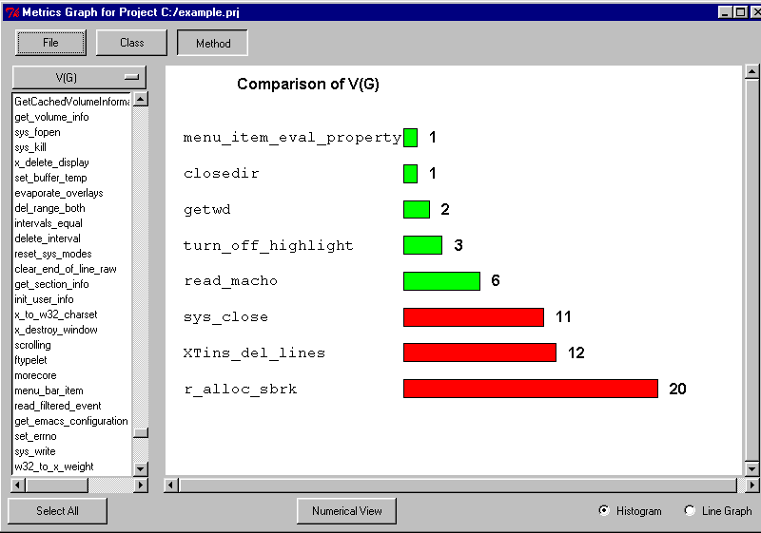

Figure: Graphical Results View

Krakatau provides line graphs to allow users to compare several symbols against several metrics in the same graph. This is a useful tool, and the area underneath the lines for any particular symbol can be interpreted as a volumetric view of all metrics for that symbol.

4.9 Reports

Software metrics form an important part of your system documentation. Krakatau provides HTML metrics reports which can be distributed through your intranet. These highlight violating symbols and violating metrics and can even be tailored to exclude unwanted metrics and symbols which do not violate metrics.

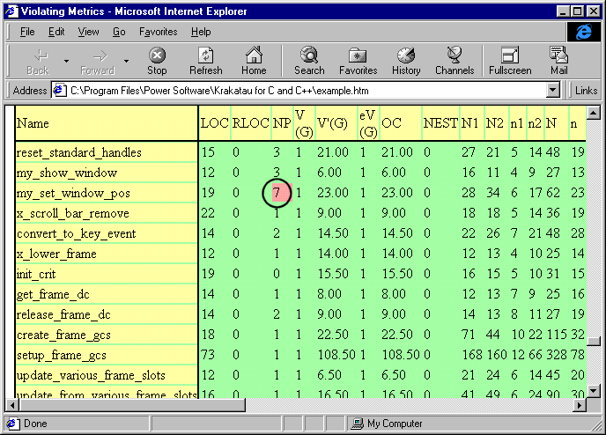

Figure: HTML Metrics Report

5 Integrating Krakatau Into Your Existing Environment

Krakatau is designed to integrate quickly and seamlessly into your existing development environment. Because Krakatau works independently of your compiler and build environment, there are no complicated set-up requirements. Krakatau provides export capabilities, command-line access and integration with configuration management systems to ensure that you can integrate it seamlessly into your existing environment.

5.1 Comma-delimited Format

Krakatau allows users to export results in comma-delimited format. This can be imported into spreadsheets allowing users to perform their own calculations and create new graphs. Also, users can import this data to their own tools to perform further processing on the metrics output.

5.2 KrakaBatch – Command-line Interface

KrakaBatch provides a command-line interface to Krakatau for automated batch mode processing. This is useful because it allows metric results to be automatically recalculated and updated as part of existing build processes. This recalculation can take place at any time without the need for user intervention.

5.3 ClearCase Integration

Krakatau is an ideal solution for ClearCase users (and indeed, users of any configuration management system). Metric results for a particular configuration can become part of the repository and recalled for later comparison. Additionally, it is possible to configure a system whereby files cannot be checked in unless they comply with selected metrics.

6 Business Benefits

Krakatau is simple to justify because the advantages are tangible and there are no hidden costs. Krakatau is unique in combining a full range of software metrics with an environment requiring minimal resources to configure and maintain. By using Krakatau, you can improve the quality of existing code and ensure that new code maintains high standards.

6.1 Low Resource Requirements

Krakatau has been optimised for ease of use and performance. Most organisations can install Krakatau and find useful quality information in less than one hour. Comprehensive online documentation explains the metrics and operation of the software and typically eliminates the need for external training.

6.2 High Acceptance

Unlike many software quality products, which are often underused or misused because of their complexity, Krakatau is used daily by developers because it is simple to use and, thanks to advanced results filtering, users can quickly see areas of potential improvement.

6.3 Wide Platform Support

Krakatau is available for Windows 95/NT as well as HPUX and Solaris. This allows you to deploy a common metrics solution across multiple development platforms. This allows every developer to use the tool, regardless of whether they use Windows or Unix.

6.4 Return On Investment

Krakatau ensures that once every developer uses the tool on a daily basis, the whole organisation begins to think about quality in a new way. Existing code is analysed and improved to reduce future maintenance costs. New code is checked for quality and interactions with the existing system to ensure that standards are maintained.

Krakatau is designed to provide return on investment from day one by helping organisations to produce more reliable, testable and maintainable code. This return continues to grow as the project lifecycle proceeds, particularly where software needs to be maintained, reused or the functionality of the application changed or enhanced in the future.
7 For Further Information

Please contact:

Power Software
Telephone +44 (0) 1224 622201
Fax +44 (0) 1244 622202
Email objects@powersoftware.com
Web http://www.powersoftware.com


